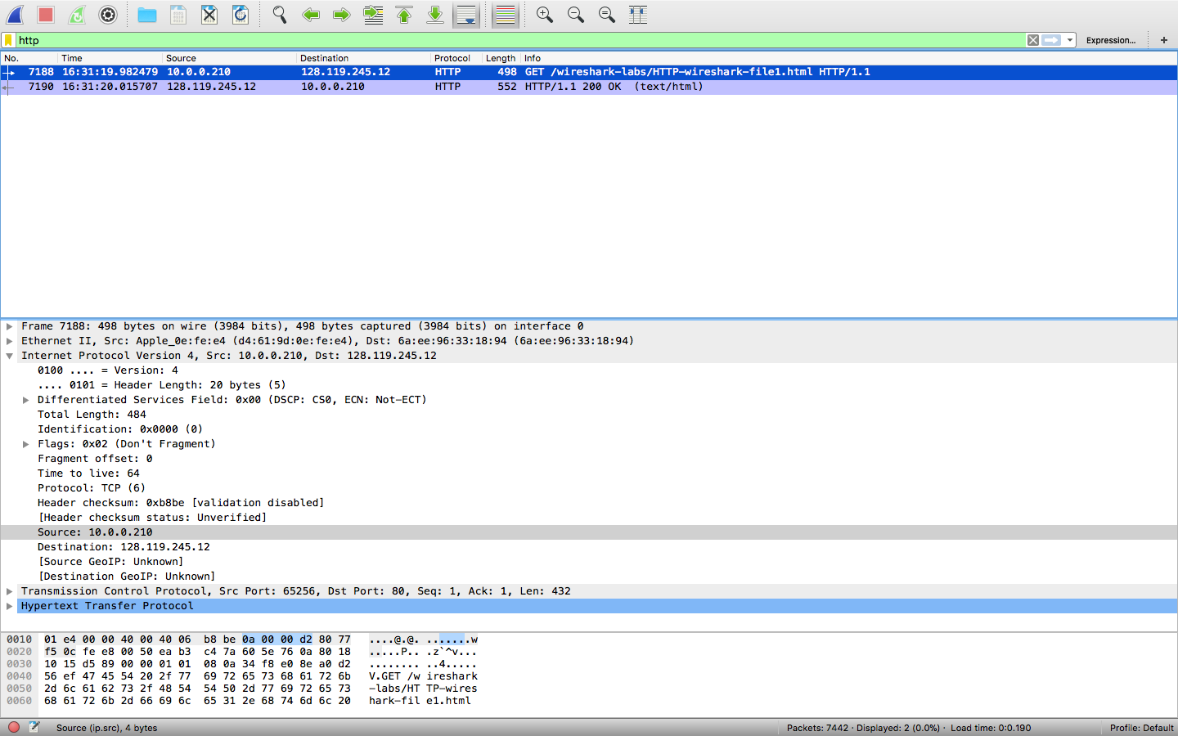

1.What is the IP address of your computer?

- IP address is 10.0.0.210

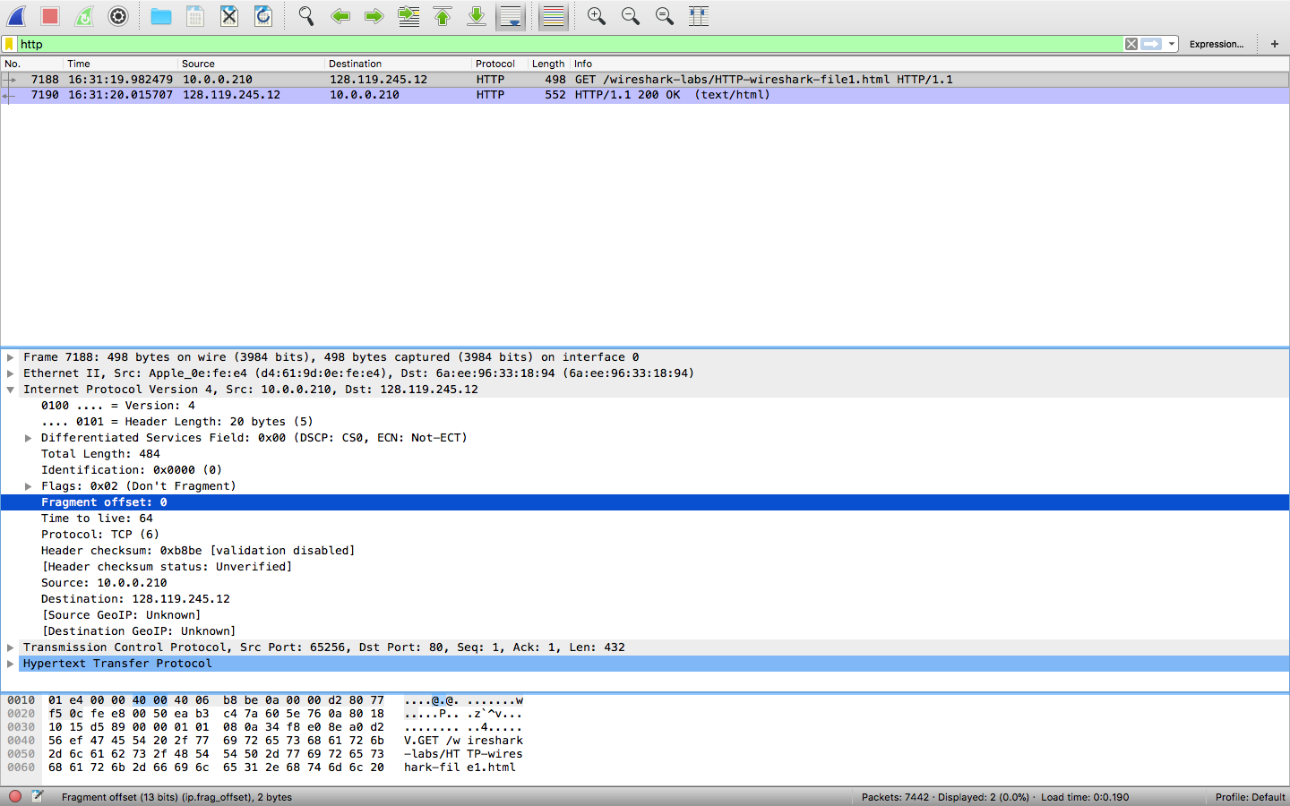

2. What is the total length of the datagram?

- Total length is 484

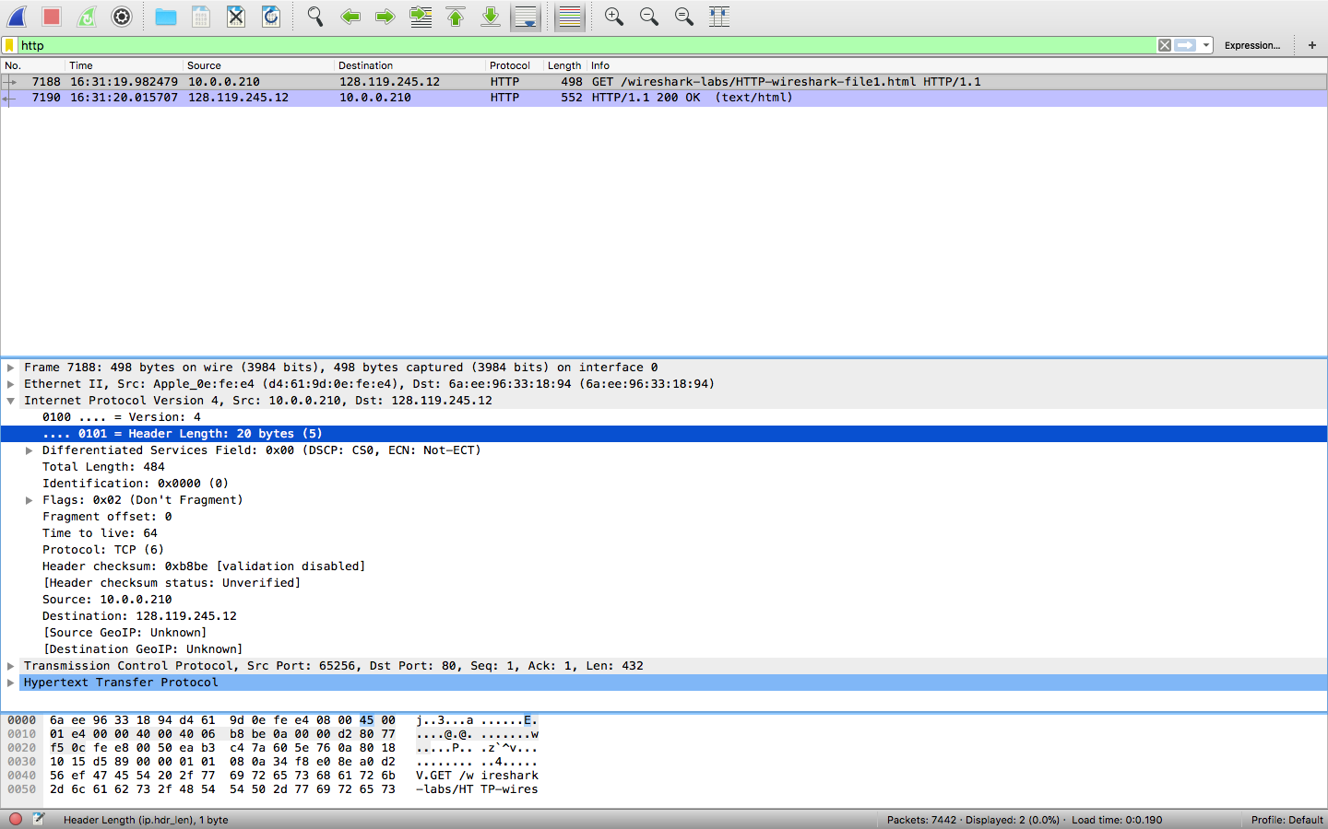

3. Has this IP datagram been fragmented?

- No, fragment offset is 0

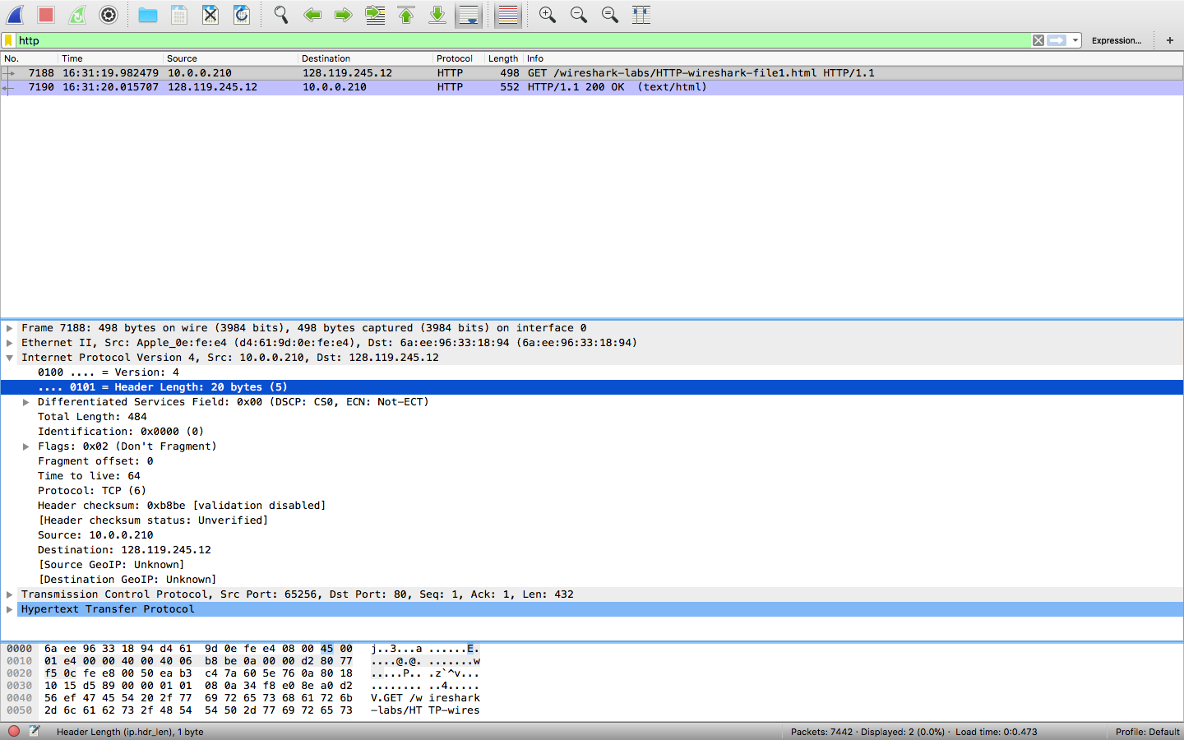

4. How many bytes are in the IP header?

- 20 bytes are in the IP header, shown in the above diagram.

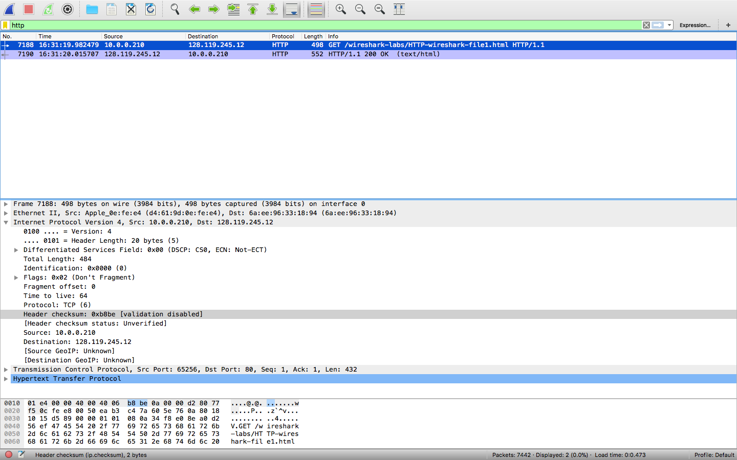

5. How many bytes are in the payload of the IP datagram? Explain how you determined the number of payload bytes.

- Total length – IP header = payload bytes

- 484 – 20 = 464